**BANK LOAN REPORT QUERY**

1. BANK LOAN REPORT SUMMARY
2. BANK LOAN REPORT OVERVIEW
3. BANK LOAN REPORT | SUMMARY

* Total Loan Application:

select count(ID) as Total_Application from Bank_Loan



* MTD Loan Application:

select count(ID) as Total_MTD_Application from Bank_Loan where MONTH(Issue_Date) = 12



* PMTD Loan Application:

select count(ID) as Total_PMTD_Application from Bank_Loan where MONTH(Issue_Date) = 11



* Total Funded Amount:

select sum(Loan_Amount) as Total_Funded_Amount from Bank_Loan



* MTD Total Funded Amount:

select sum(Loan_Amount) as Total_Funded_Amount from Bank_Loan where month(issue_date) = 12



* PMTD Total Funded Amount:

select sum(Loan_Amount) as Total_PMTD_Funded_Amount from Bank_Loan where month(issue_date) = 11



* Total Amount Received:

select sum(Total_Payment) as Total_Amt_Collect from Bank_Loan



* MTD Total Amount Received:

select sum(Total_Payment) as Total_MTD_Amt_Collect from Bank_Loan WHERE MONTH(Issue_Date) = 12



* PMTD Total Amount Received:

select sum(Total_Payment) as Total_PMTD_Amt_Collect from Bank_Loan WHERE MONTH(Issue_Date) = 11



* Average Interest Rate:

select AVG(Int_Rate)*100 as Avg_Int_Rate from Bank_Loan



* MTD Average Interest Rate:

select AVG(Int_Rate)*100 as Avg_MTD_Int_Rate from Bank_Loan where month(issue_date) = 12



* PMTD Average Interest Rate:

select AVG(Int_Rate)*100 as Avg_PMTD_Int_Rate from Bank_Loan where month(issue_date) = 11



* Average DTI:

select AVG(Dti)*100 as Avg_Dti from Bank_Loan



* MTD Average DTI:

select avg(dti)*100 as MTD_Avg_Dti from Bank_Loan where month(issue_date) = 12



* PMTD Average DTI:

select avg(dti)*100 as PMTD_Avg_Dti from Bank_Loan where month(issue_date) = 11



Good Loan Issued

* Good Loan Percentage:

select (count(case when loan_status = 'Fully Paid' or loan_status = 'Current' then id end)*100.0)/ count(id) as Good_Loan_Percentage from Bank_Loan



* Good Loan Application:

select count(id) as Good_loan_application from Bank_Loan where loan_status = 'fully paid' or Loan_Status = 'current'



* Good Laon Funded Amount:

select sum(loan_amount) as Good_loan_funded_amount from Bank_Loan where Loan_Status = 'fully paid' or Loan_Status = 'current'



* Good Laon Amount Received:

select sum(Total_payment) as Good_loan_amount_received from Bank_Loan where Loan_Status = 'fully paid' or Loan_Status = 'current'



Bad Loan Issued

* Bad Loan Percentage:

select (COUNT(case when loan_status = 'charged off' then id end)*100.0)/

count(id) as Bad_Loan_percentage from Bank_Loan



* Bad Loan Application:

select count(id) as Bad_loan_application from Bank_Loan where Loan_Status = 'Charged off'



* Bad Loan Funded Amount:

select sum(Loan_Amount) as Bad_loan_funded_amount from Bank_Loan where Loan_Status = 'charged off'



* Bad Loan Amount Received:

select sum(total_payment) as Bad_loan_amount_received from Bank_Loan where Loan_Status = 'charged off'



Loan Status

select

loan_status,COUNT(id) as loan_count,

sum(loan_amount) as total_loan_funded,

sum(total_payment) as total_loan_received,

avg(int_rate *100) as Interest_rate,

avg(dti * 100) as DTI

from Bank_Loan

group by Loan_Status

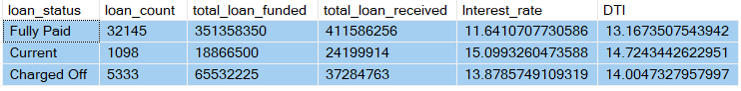

Loan Status of MTD

SELECT Loan_status,

sum(loan_amount) as MTD_Total_loan_funded,

sum(total_payment) as MTD_Total_loan_received

from Bank_Loan

where MONTH(issue_date) = 12

group by Loan_Status

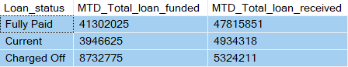

1. Bank Loan Report Overview

Month

select month(issue_date) as Month_Number,

DATENAME(month,issue_date) as Month_Number,

count(id) as Total_Loan_Application,

sum(loan_amount) as Total_Funded_Amount,

sum(total_payment) as Total_Amount_Received

from Bank_Loan

group by month(issue_date), datename(month,issue_date)

order by month(issue_date)

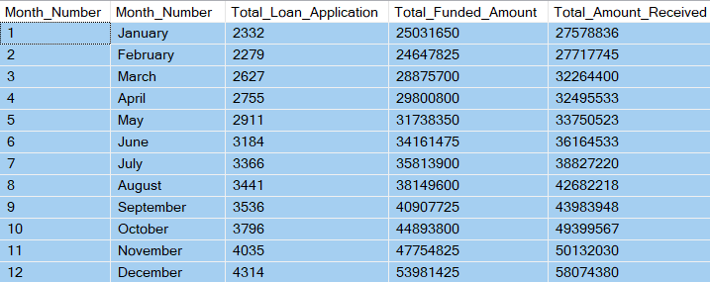

State

select address_state as State,

count(id) as Total_Loan_Application,

sum(loan_amount) as Total_Funded_Amount,

sum(total_payment) as Total_Amount_Received

from bank_loan

group by address_state

order by Address_State

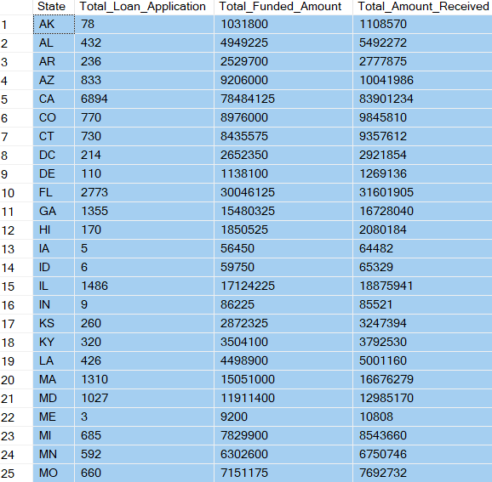

Term:

select term as Term,

count(id) as Total_Loan_Application,

sum(loan_amount) as Total_Loan_Application,

sum(total_payment) as Total_Amount_Received

from Bank_Loan

group by Term

order by Term



Employee Lenth:

select Emp_length as Employee_Lenth,

COUNT(id) as Total_Loan_Applications,

sum(loan_amount) as Total_Funded_Amount,

sum(total_payment) as Total_Amount_Received

from Bank_Loan

group by Emp_Length

order by Emp_Length

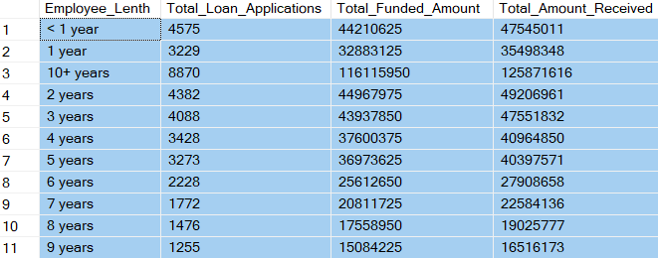

Purpose:

select purpose as Purpose,

count(id) as Total_Loan_Applications,

sum(loan_amount) as Total_Funded_Amount,

sum(total_payment) as Total_Amount_Received

from bank_loan

group by purpose

order by purpose

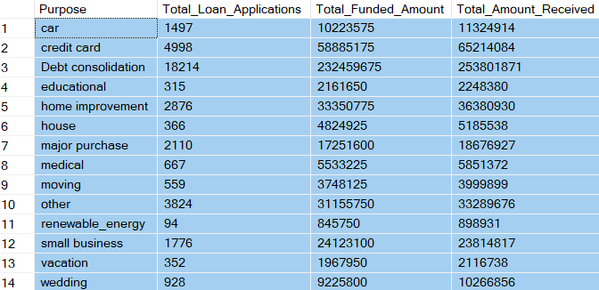

Home Ownership:

select home_ownership as Home_Ownership,

count(id) as Total_Loan_Applications,

sum(loan_amount) as Total_Loan_Application,

sum(total_payment) as Total_Amount_Received

from Bank_Loan

group by Home_Ownership

order by Home_Ownership

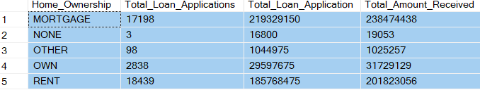

Grade Wise:

select grade as Grade,

COUNT(id) as Total_Loan_App,

sum(loan_amount) as Total_Funded_Amount,

sum(total_payment) as Total_Amount_Received

from Bank_Loan

group by Grade

order by Grade

